Lab 1

Talal Jawaid

10/25/2018

CSC 138

Part 1

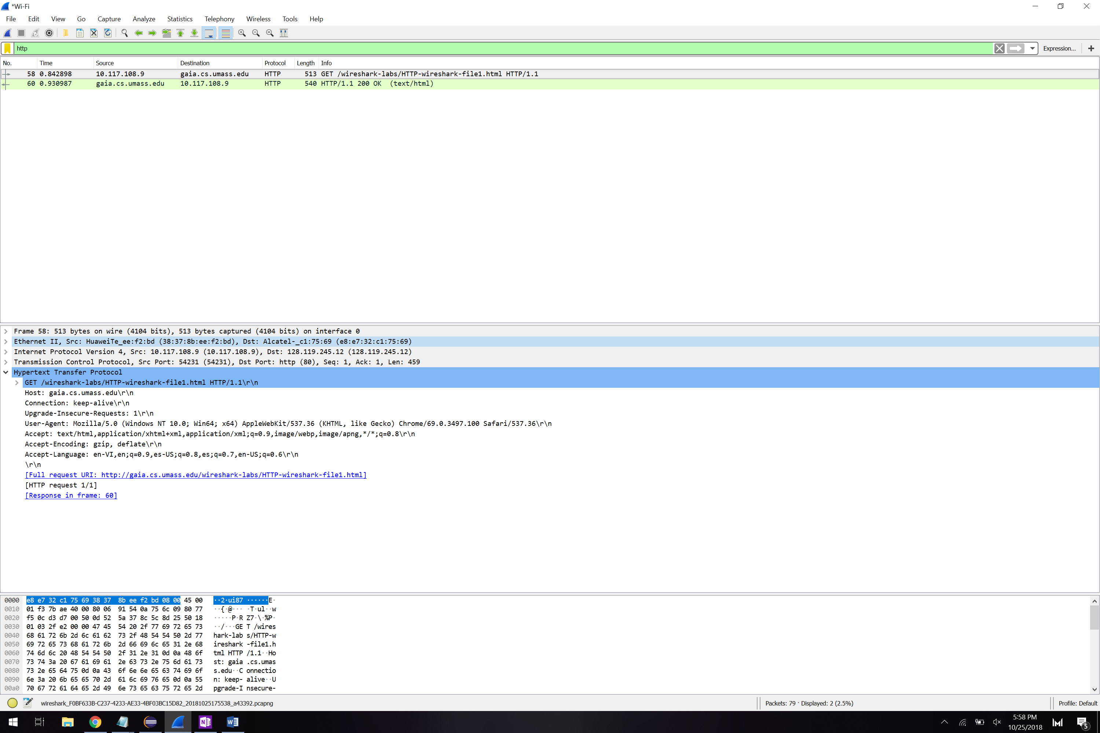

1. Is your browser running HTTP version 1.0 or 1.1? What version of HTTP is the server running?

Both my browser and the server are running HTTP version 1.1

1. What languages (if any) does your browser indicate that it can accept to the server?

en-VI,en;q=0.9,es-US;q=0.8,es;q=0.7,en-US;q=0.6

The browser indicates that it can accept English and Spanish.

1. What is the IP address of your computer? Of the gaia.cs.umass.edu server?

My IP Address is 10.117.108.9

The server IP Address is 128.119.245.12

1. What is the status code returned from the server to your browser?

The HTTP status code returned is 200, OK

1. When was the HTML file that you are retrieving last modified at the server?

The HTML file was last modified Thu, Oct 2018 0:5:59:01 GMT

1. How many bytes of content are being returned to your browser?

128 bytes of data are being returned to my browser.

1. By inspecting the raw data in the packet content window, do you see any headers within the data that are not displayed in the packet-listing window? If so, name one

I don’t see any within the data that are not displayed in the packet listing window.

**Part 2.**

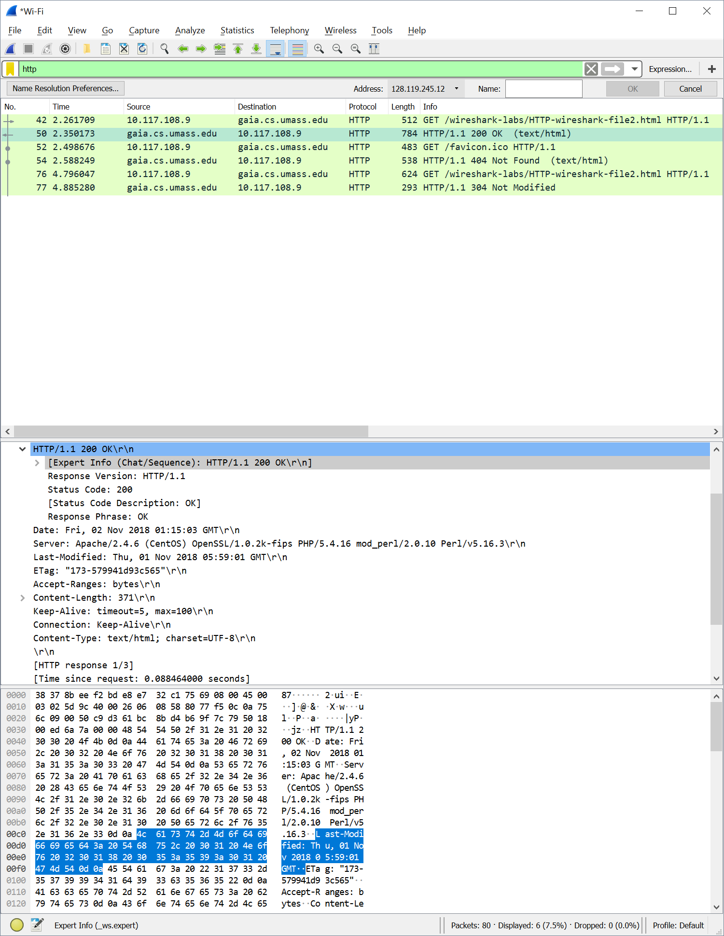

1. Inspect the contents of the first HTTP GET request from your browser to the server. Do you see an “IF-MODIFIED-SINCE” line in the HTTP GET?

I don’t see an If-MODIFIED-SINCE line in the initial HTTP Get request.

1. Inspect the contents of the server response. Did the server explicitly return the contents of the file? How can you tell?

The server explicitly returned the contents of the file. You can tell by inspecting the packet returned to my computer. By viewing the line based text data, you can read the exact same text that appears on the website through the browser.

1. Now inspect the contents of the second HTTP GET request from your browser to the server. Do you see an “IF-MODIFIED-SINCE:” line in the HTTP GET? If so, what information follows the “IF-MODIFIED-SINCE:” header?

You can see the time stamp given for the If Modified Since header, which is Thu, 01 Nov 2018 05:59:01 GMT

1. What is the HTTP status code and phrase returned from the server in response to this second HTTP GET? Did the server explicitly return the contents of the file? Explain. ‘

The server returned a HTTP 304 Not Modified status code. The server did not return the text of the file since it hadn’t been modified since the given time stamp.

Part 3.

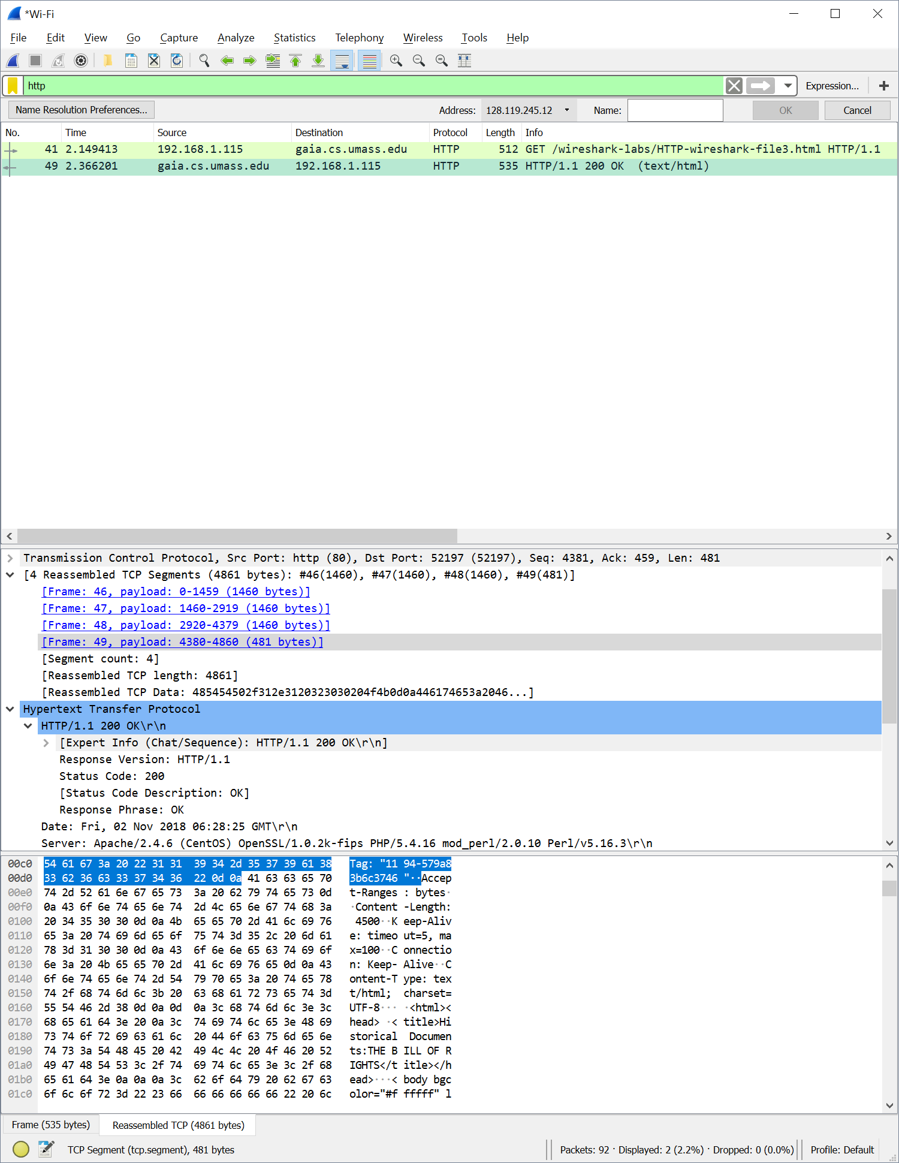

1. How many HTTP GET request messages did your browser send? Which packet number in the trace contains the GET message for the Bill or Rights?

Packet 41 in the trace contains the GET message for the Bill of Rights

1. Which packet number in the trace contains the status code and phrase associated with the response to the HTTP GET request?

Packet 49 contains the status code and phrase for the HTTP 200 OK response.

1. What is the status code and phrase in the response?

HTTP 200 OK

1. How many data-containing TCP segments were needed to carry the single HTTP response and the text of the Bill of Rights?

4 TCP segments were required to carry the single HTTP Response and text of the Bill of Rights.



Part 4.

1. How many HTTP GET request messages did your browser send? To which Internet addresses were these GET requests sent?
2. Can you tell whether your browser downloaded the two images serially, or whether they were downloaded from the two web sites in parallel? Explain.

Part 5.

1. What is the server’s response (status code and phrase) in response to the initial HTTP GET message from your browser?

1. When your browser’s sends the HTTP GET message for the second time, what new field is included in the HTTP GET message?